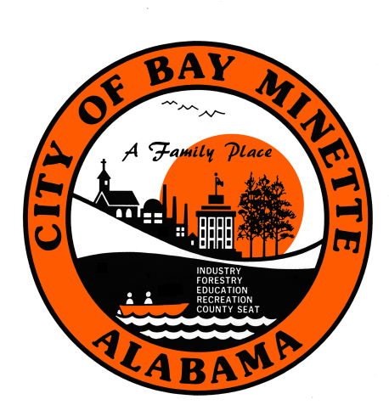

NOTICE OF PUBLIC HEARING FOR PROPOSED REDISTRICTING OF THE CITY OF BAY MINETTE

The Bay Minette City Council has set a Public Hearing on Monday, December 16, 2024 at the Bay Minette City Council Meeting at 6:00 p.m. to discuss the proposed redistricting of the City of Bay Minette based on the 2020 decennial census. The meeting will be held in the City Council Chambers at the Bay Minette City Hall located at 301 D’Olive Street, Bay Minette, Alabama.

A public viewing of the proposed redistricting maps with a representative present to assist with questions will be available on December 12, 2024 from 2:00-3:00 p.m. and 4:30-6:00 p.m. in the First Floor Conference Room at Bay Minette City Hall located at 301 D’Olive Street. You may also view the proposed redistricting plans, by visiting the City of Bay Minette’s website at www.cityofbayminetteal.gov.

If you have questions or need assistance, please contact Tammy Smith, City Administrator, at 251-580-1619.

