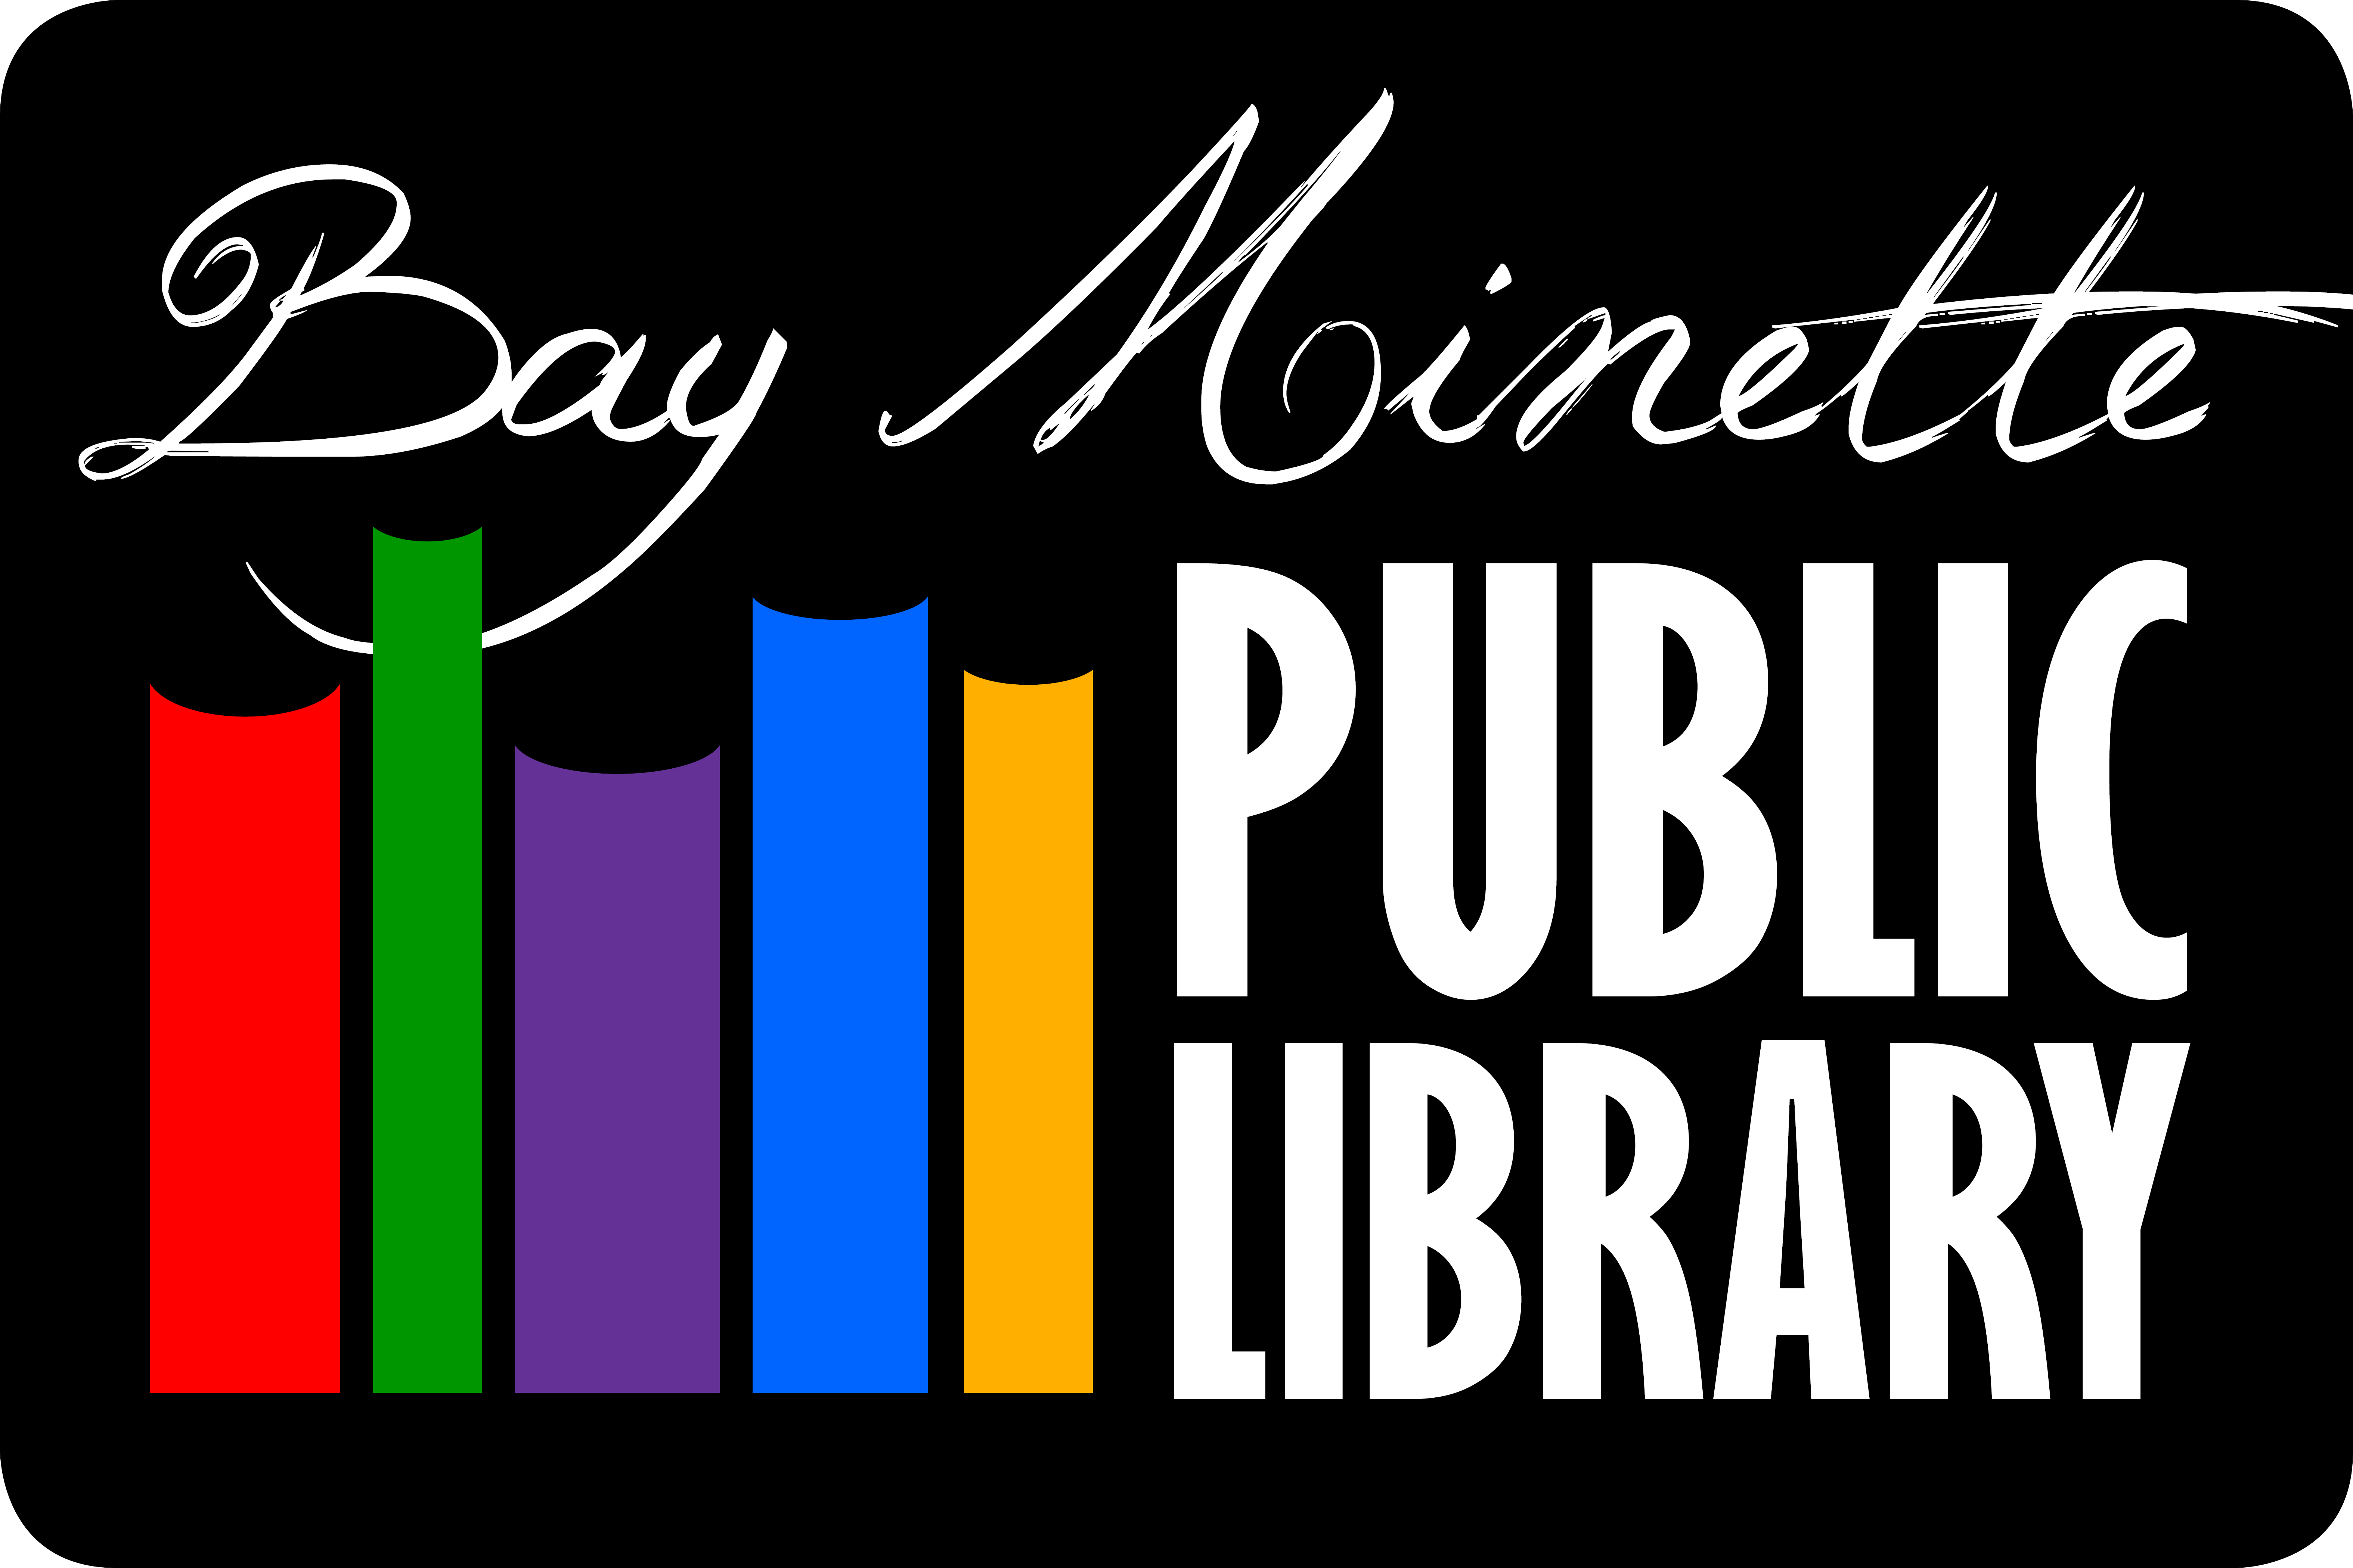

The Bay Minette Public Library Board will meet Monday, September 23rd
@ 5:30 p.m.
Upstairs in the
Program Room.
Posted Bay Minette Public Library, City Hall and NBU.

