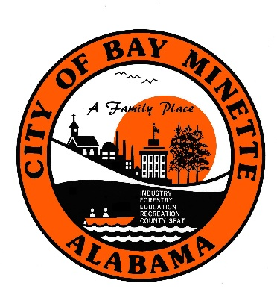

Bay Minette Housing Authority
2023-2024 Meeting Dates

Meetings are held at 5:00 p.m. at the Housing Authority.

March 28, 2024
June 27, 2024
September 26, 2023
December 5, 2024

